|  |  |
| --- | --- |
| **Project – External Document** |  |
| COMP6800001  Human and Computer Interaction |
| Even Semester Year 2021/2022 |

* Project Title

ADex Legends

* Introduction

ADex Legends is a website for a popular game called Adex Legends

* Report / Documentation

1. HOME

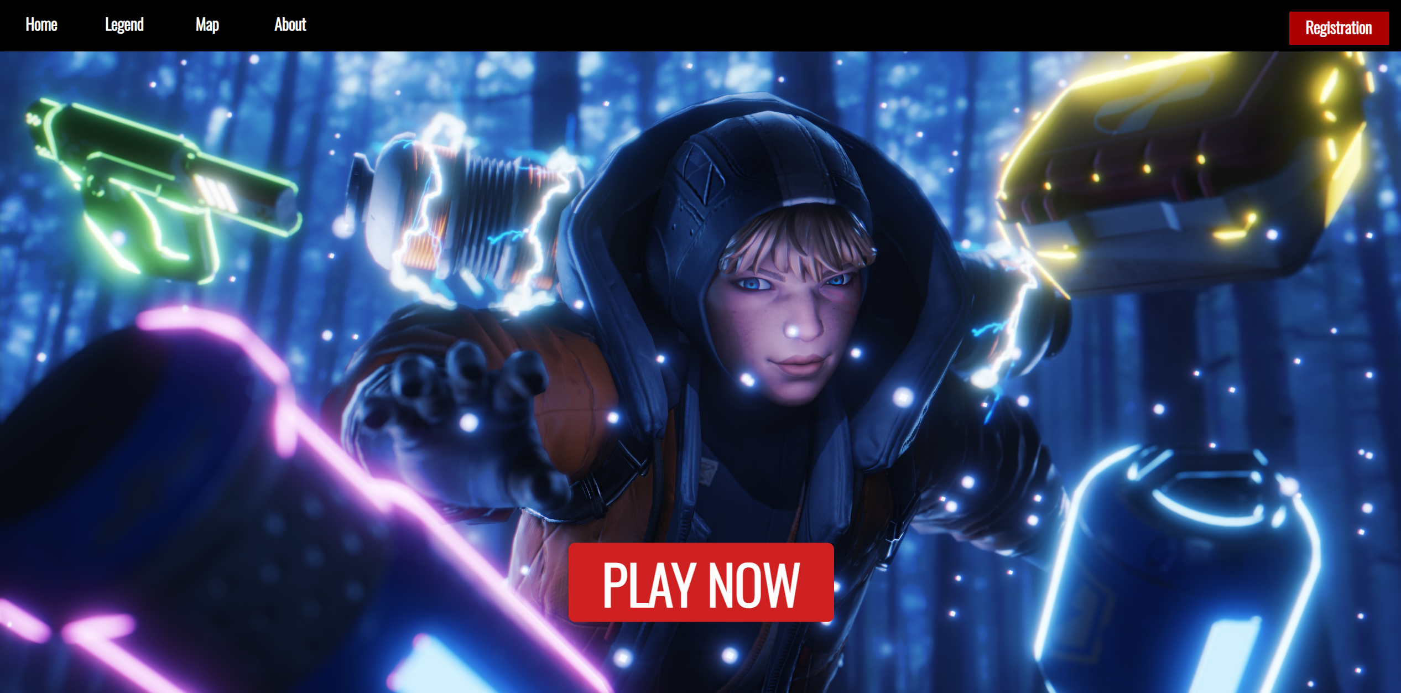

1. LEGEND

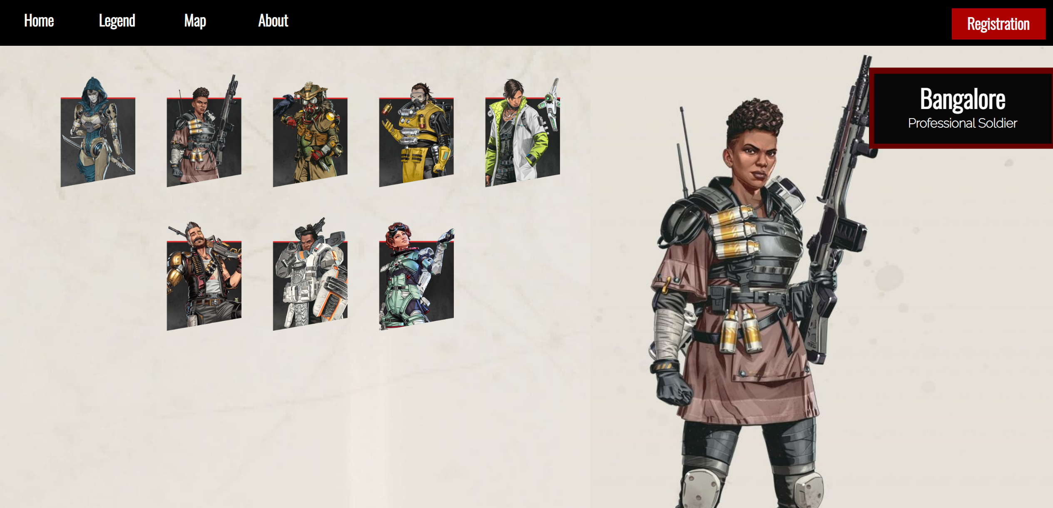

1. MAP (ARENA)

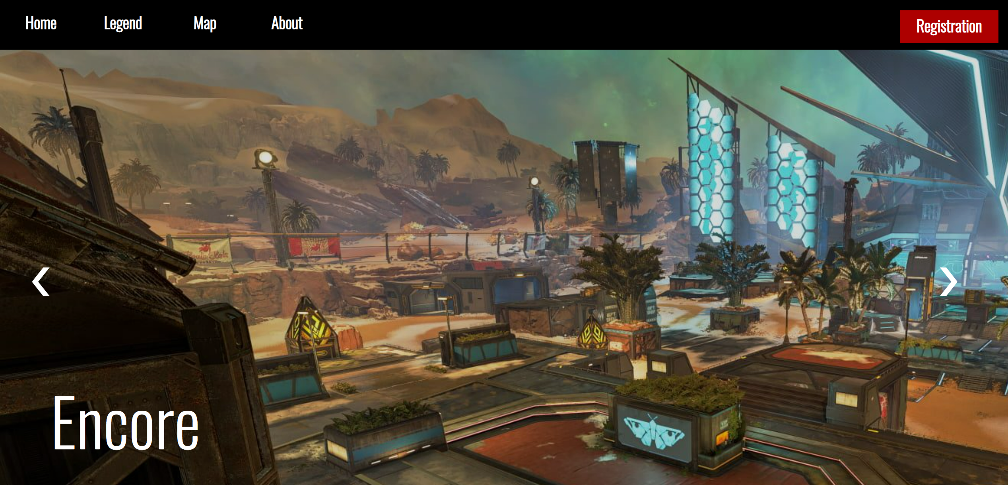

1. MAP (BATTLE ROYALE)

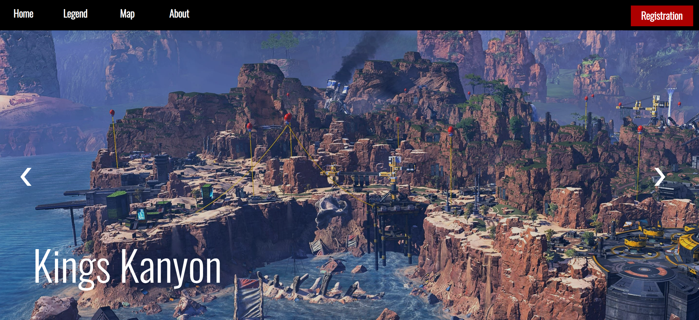

1. ABOUT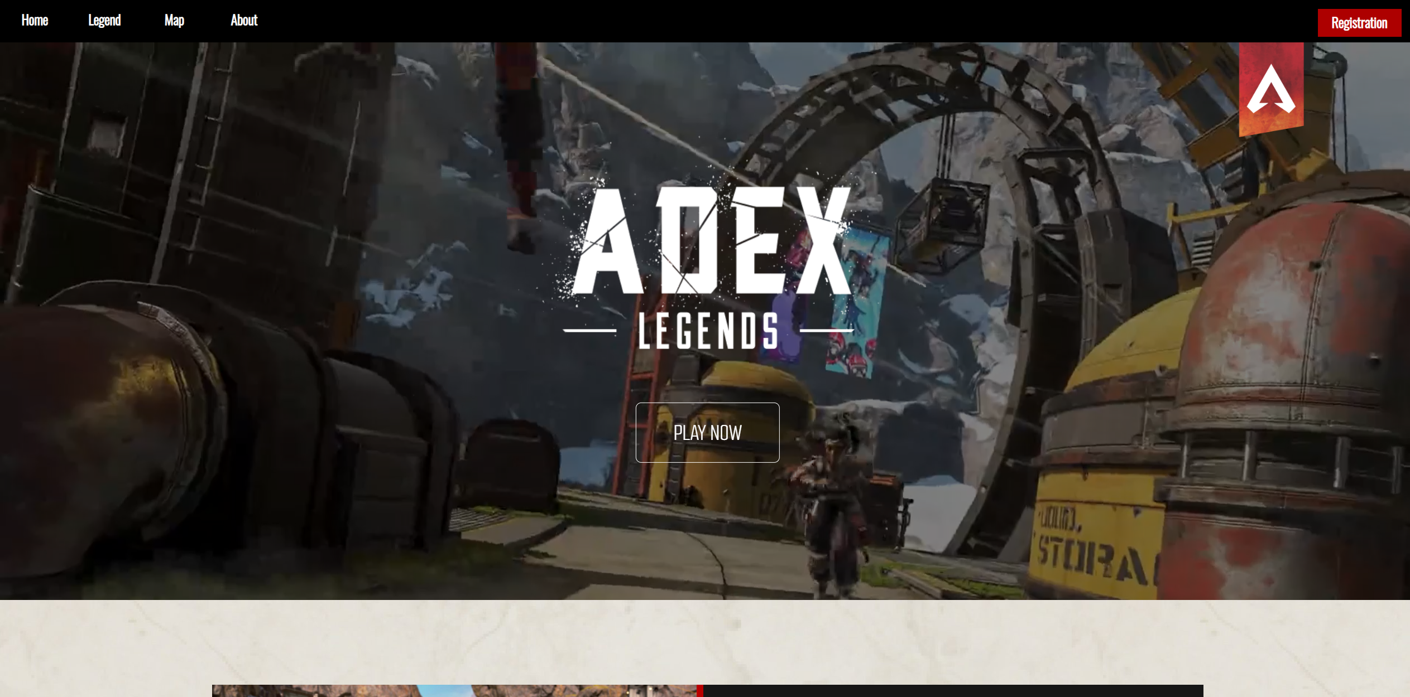
2. REGISTRATION

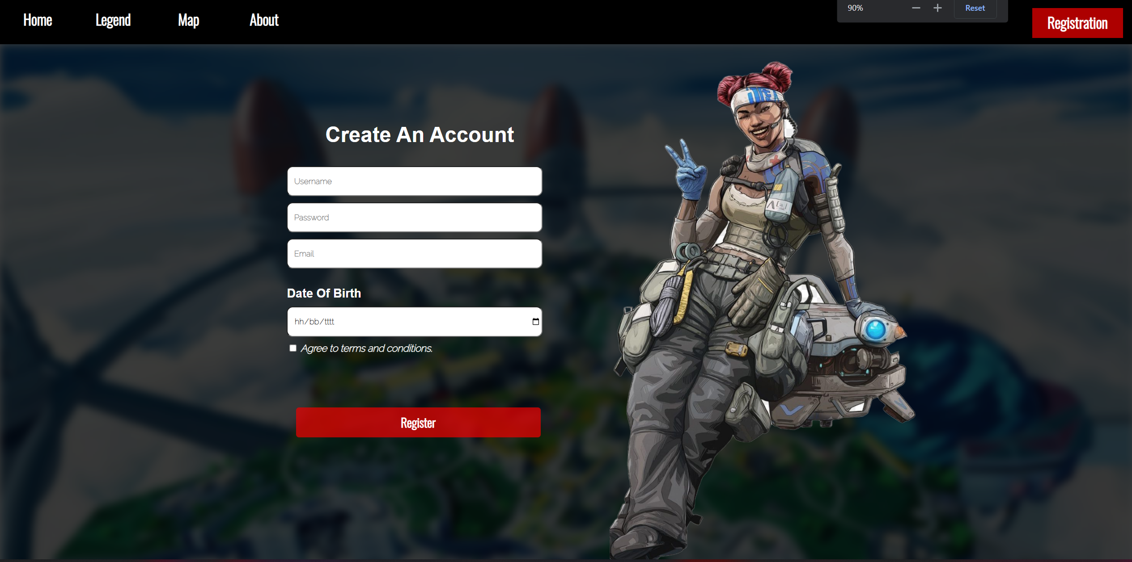

1. FOOTER



1. NAVBAR



* Reference
* About-us = https://www.ea.com/games/apex-legends
* Character – card = <https://www.ea.com/games/apex-legends/about/characters>
* Ash = <https://www.ea.com/games/apex-legends/about/characters/ash>
* Bangalore = <https://www.ea.com/games/apex-legends/about/characters/bangalore>
* Bloodhound = <https://www.ea.com/games/apex-legends/about/characters/bloodhound>
* Caustic = <https://www.ea.com/games/apex-legends/about/characters/caustic>
* Crpyto = <https://www.ea.com/games/apex-legends/about/characters/crypto>
* Fuze = <https://www.ea.com/games/apex-legends/about/characters/fuze>
* Giblatar = <https://www.ea.com/games/apex-legends/about/characters/giblatar>
* Horizon = <https://www.ea.com/games/apex-legends/about/characters/horizon>
* Instagram = https://www.citypng.com/photo/8192/hd-square-white-instagram-logo-icon-png
* Discord = https://www.pngitem.com/middle/JToxxm_white-discord-logo-png-png-free-discord-icon/
* Twitter = https://toppng.com/photo/79238/twitter-icon-white-transparent
* Youtube = <http://clipart-library.com/clipart/dc4LABqni.htm>
* Achievement = <https://media.contentapi.ea.com/content/dam/apex-legends/images/2018/12/apex-grid-tile-battle-royale.png.adapt.crop16x9.652w.png>
* Death = <https://media.contentapi.ea.com/content/dam/apex-legends/images/2018/12/apex-grid-tile-lawless-world.png.adapt.crop16x9.652w.png>
* Wingman = <https://media.contentapi.ea.com/content/dam/apex-legends/images/2018/12/apex-grid-tile-sci-fi-wild-west.png.adapt.crop16x9.652w.png>
* Kings kanyon = <https://wall.alphacoders.com/big.php?i=991594>
* Island map = <https://www.uhdpaper.com/2021/09/apex-legends-island-map-4k-230e.html?m=1>
* Encore = <https://www.teahub.io/viewwp/iTJxwo_apex-legends-full-map/>
* Habitat = <https://ca.roccat.com/blogs/news/apex-legends-season-12-habitat-arenas-map-everything-we-know-xbox-playstation-pc>
* Overflow = <https://9to5toys.com/2021/07/12/apex-legends-thrillseekers-overflow-arenas-map/>
* Partycrasher = <https://gamersantai.com/wp-content/uploads/2021/04/apex-legends-arenas-blog-party-crasher.jpg.adapt_.1456w-1140x641.jpg>
* Phase Runner = <https://www.slythergames.com/2021/05/18/apex-legends-complete-arena-mode-map-guides/>
* Rotating Map = <https://progameguides.com/apex-legends/all-battle-royale-maps-in-rotation-for-apex-legends-season-13-saviors/>
* Encore Map = <https://liquipedia.net/apexlegends/Encore>
* Habitat Map = <https://liquipedia.net/apexlegends/Habitat>
* Overflow Map = <https://liquipedia.net/apexlegends/Overflow>
* Phase Runner = <https://liquipedia.net/apexlegends/PhaseRunner>
* Olympus = <https://mmoculture.com/id/2021/04/apex-legends-mungkin-akan-memberikan-perubahan-kepada-map-olympus/>
* Storm Point = https://statics.indozone.id/local/617ad84f78d45.jpg
* World Edge = <https://i0.wp.com/gamingonphone.com/wp-content/uploads/2022/03/apex-legends-mobile-worlds-edge-map.jpg?w=1100&ssl=1>
* About us = <https://www.youtube.com/watch?v=UMJb_mkqynU&t=39s&ab_channel=ApexLegends>
* Background = <https://charlieintel.com/wp-content/uploads/2022/01/defiance.jpg>
* Blackbg = <https://www.freepik.com/free-photos-vectors/black-background>
* Gif2 = <https://id.pinterest.com/pin/809944314240234964/>
* Gif = <https://bryndeavour.tumblr.com/post/186259186008>
* Home = <https://wallpaperaccess.com/apex-legends-wattson>
* Madmaggie = <https://www.youtube.com/watch?v=dIIbltnAcHs&t=22s&ab_channel=ApexLegends>
* Life Line = <https://www.pngitem.com/middle/hRiJhJh_lifeline-lifeline-png-apex-legends-transparent-png/>
* Watson = <https://www.pngitem.com/middle/hmJmRRT_apex-legends-wattson-hd-png-download/>
* News = <https://www.ea.com/games/apex-legends/news>
* Group Member
* 2501972221 – Justine Winata
* 2540121096 - Richard Santoso